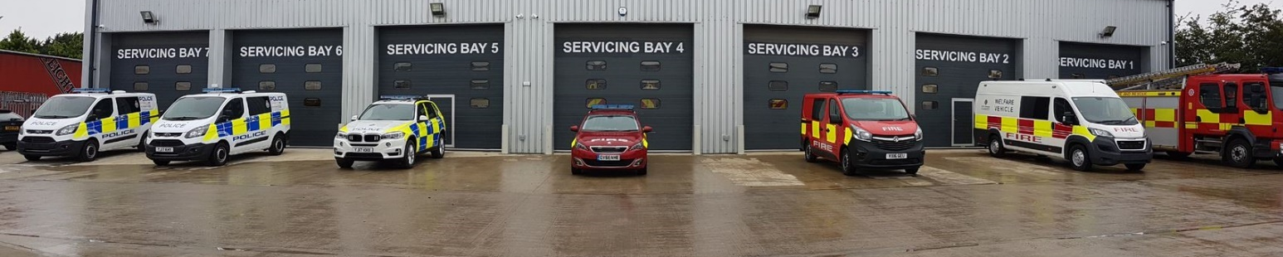
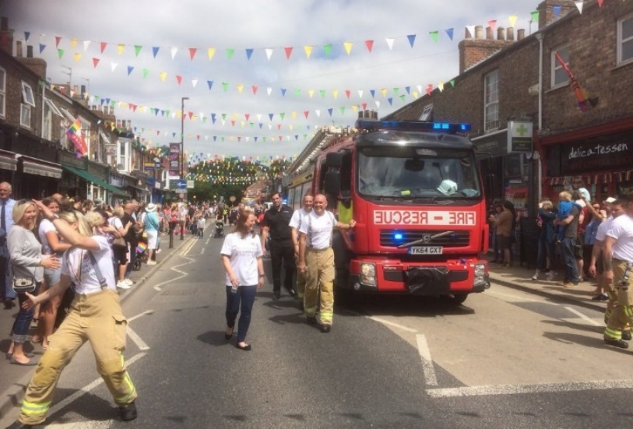

JUNE 2021
____________
North Yorkshire Police, Fire and Crime Commissioner

Interim Chief Fire Officer

North Yorkshire

Recruitment Pack

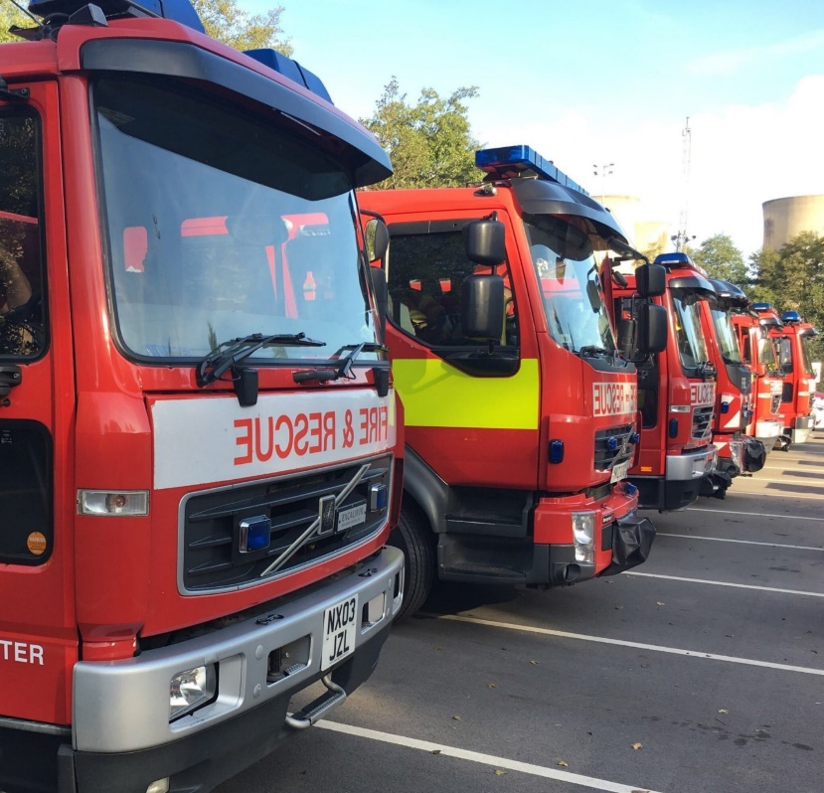
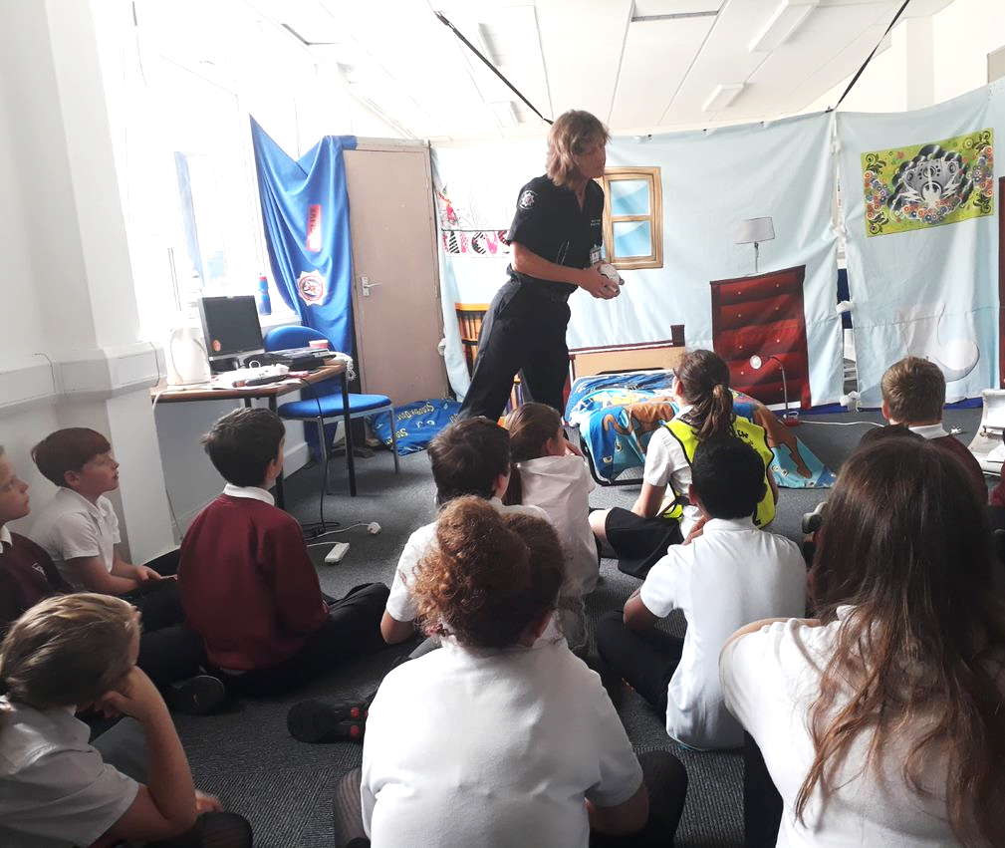
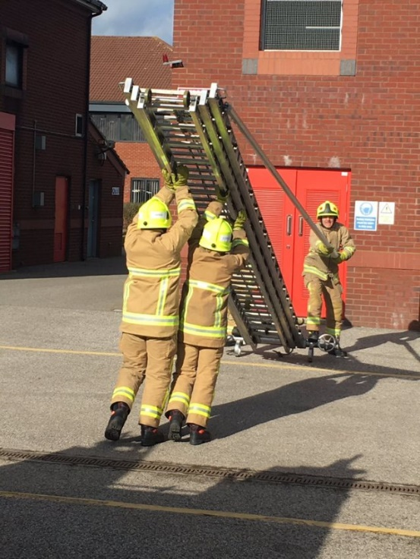
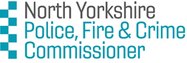

RECRUITMENT PACK CONTENTS

Message from the North Yorkshire Police, Fire and Crime Commissioner | p2
Advertisement | p4
Recruitment Timetable and Process | p6
Role Profile | p7
NFCC Leadership Framework - Personal Qualities and Attributes | p12
National Occupational Standards Information | p17
About  - North Yorkshire  - North Yorkshire Fire and Rescue Service  - ENABLE North Yorkshire | p18
Terms and Conditions | p21
Background Reading | p23

MESSAGE FROM THE NORTH YORKSHIRE
POLICE, FIRE AND CRIME COMMISSIONER

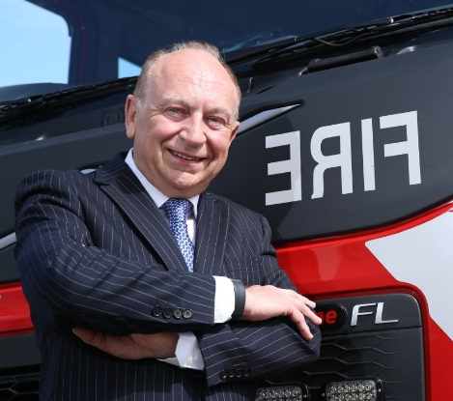
Thank you for your interest in the role of Interim Chief Fire Officer for North Yorkshire Fire and Rescue Service.
The current postholder has decided to retire and we are looking to appoint an exceptional individual who will continue the work of modernising the way the Fire and Rescue Service operates in North Yorkshire at an important time for the future of the organisation.
Responsibility for governance and oversight of North Yorkshire Fire and Rescue Service transferred to the Police, Fire and Crime Commissioner in November 2018 and, as the newly elected Commissioner, I am determined to ensure we continue developing a Service which is fit for the future
We have a committed, determined and passionate workforce who make a real difference to keeping the people of North Yorkshire and York safe and feeling safe. Resources are always constrained, and we need to continue the work to ensure we have a strong and sustainable organisation which innovative in its response and preventative practices.
Over the coming year, the successful candidate will be responsible for implementing a new Integrated Risk Management Plan – known locally as the Risk and Resource Model. Given this challenge, applicants for the position will need to demonstrate experience of implementing change in a timely manner and driving transformation with the enthusiasm and commitment to bring everyone together.
Diversity is also a real issue for our Service, and I will be looking to the successful applicant to really catalyse a step change in this area.
This is an exciting opportunity to join and lead the Service, to ensure our communities remain some of the safest to live and work in the country, and deliver a modern, reactive and respected organisation which protects people and property and saves lives.
Details of the role and how to apply are in this pack, and if you would like an informal conversation with me about the role, please do get in touch.
With best wishes
Philip Allott
North Yorkshire Police, Fire and Crime Commissioner
ADVERTISEMENT

NORTH YORKSHIRE FIRE AND RESCUE SERVICE – CHIEF FIRE OFFICER
INTERIM OPPORTUNITY FOR UP TO 12 MONTHS
£121,352-£133,837
Application closing date: Monday 28 June, 9am
We have an exciting opportunity for an ambitious, innovative and highly experienced individual to take up the role of Chief Fire Officer for North Yorkshire Fire & Rescue Service on an interim basis, following the retirement of the current postholder.
We are looking for an exceptional individual to bring a new approach to the delivery of fire and rescue services in North Yorkshire that can deliver real and sustainable benefits for the public, shaping and securing the future of the Service.
This is a time of great change for the Service, with the transfer of governance to the Police, Fire and Crime Commissioner in November 2018 and the recent introduction of enable North Yorkshire, a formal collaboration arrangement bringing together support staff of North Yorkshire Fire and Rescue Service and North Yorkshire Police. It will be a key requirement of the role for the seconded Chief Fire Officer to work in partnership to ensure the benefits of this collaborative work are maximised.
The Chief Fire Officer will report directly to a newly elected and Police, Fire and Crime Commissioner, with dynamic ambitions for the service - and therefore you should communicate well and provide professional guidance to the PFCC as single elected office holder. You will be responsible for implementing a new Integrated Risk Management Plan, known locally as the Risk and Resource Model, so it is important that candidates are able to demonstrate experience of implementing change in a timely manner.
The successful candidate must be committed to driving forward transformation in respect of equality, diversity and inclusion (EDI) priorities, ensuring that we improve to better reflect and serve the diverse communities of North Yorkshire and the City of York.
The successful candidate will be a great communicator, with the ability to build and maintain strong working partnerships both inside NYFRS and across the partnership landscape. Internally, there are excellent relationships with representative bodies including the local FBU and it is key that the new appointee will be able to continue to develop these.
Applicants must currently operate at competent Assistant Chief Officer level (or local equivalent) or above and display strong evidence of operating at a strategic level within a Fire and Rescue Service. The provision of Incident Command leadership is essential and applicants must currently operate at Gold Commander level or equivalent to apply.
Applicants are also required to evidence relevant academic achievement or to demonstrate equivalent experience.
The role is based in Northallerton but the applicant will be expected to travel across North Yorkshire and the City of York to meet the requirements of the role and the Continuous Duty System.
Ideally the successful candidate will have the support of their current host organisation to commence in role with immediate effect in July 2021 to allow for a suitable handover period with the outgoing Chief Fire Officer.

The interim role will be offered on a secondment basis for a successful external applicant – or on a temporary promotion basis for a successful applicant currently in NYFRS service.

Informal conversation
If you would like an informal conversation about this opportunity with Philip Allott, Police, Fire and Crime Commissioner, please email PFCC Executive Support on PFCCexecutivesupport@northyorkshire-pfcc.gov.uk.

Application
To apply, candidates should read the full recruitment pack and complete the application form, in which you are required to provide a CV and supporting statement. Please use the links below to access the relevant documents.
Selection process
Assessments are scheduled to take place between Wednesday 30 June to Friday 02 July 2021 at Alverton Court, Northallerton.
The assessment process will include a presentation and competency-based interview. Details of the presentation topic will be shared with all applicants in advance of the assessment date.

Terms and Conditions
The terms and conditions of the opportunity are as follows:
- The secondment opportunity is open to both internal and external candidates.
- For a successful internal candidate, this will be a temporary promotion.
- For a successful external candidate, this will be a secondment opportunity, and you will retain your current employment Terms and Conditions with your existing service
2. Annual salary for the secondment will be £121,352-£133,837, including operational allowance.
3. Travel, accommodation and subsistence costs appropriately incurred while on secondment will be covered, based on consideration of current service location and to be finalised with the successful candidate, with subsistence costs aligned to those claimable by the Police, Fire and Crime Commissioner.

RECRUITMENT TIMETABLE AND PROCESS

Timetable
Opportunity for informal conversation with the PFCC | up to and including 18 June
Application closing date | 28 June (9am)
Sift process and shortlisting | 28 June
Invitation to interview | 29 June
Presentation & interview (Northallerton) | 30 June – 02 July

The preferred candidate is requested to be available to attend a Confirmation Hearing by the Police, Fire and Crime Panel. Claims for reasonable travel and subsistence costs for these two trips will be considered.
Confirmation hearing at the Police, Fire and Crime Panel | TBC

Informal conversation and queries
If you have any queries or would like an informal conversation about this opportunity with Philip Allott, Police, Fire and Crime Commissioner, please email PFCC Executive Support on PFCCexecutivesupport@northyorkshire-pfcc.gov.uk.

Applications
You are strongly advised to read all sections of this pack and familiarise yourself with the Commissioner’s Fire and Rescue Plan and other documents listed, before completing and submitting your application.
The application form is available online via:
https://northyorkshirefrs.engageats.co.uk/ViewVacancyV2.aspx?enc=mEgrBL4XQK0+ld8aNkwYmP3eXRdbm9HwZWDuQPF2CKWdX/9Vzl3KDWZil2LouZ430rg7bCAv6JqItqnNEIwMaOAtllLMhHDMgDVndAb7AzBGv1llP1Vx3+oiJ8U6Rz8wIToDBt93VRvCnbppQwe65g==

ROLE PROFILE

Role Title | Interim Chief Fire Officer | Reporting To | Police, Fire & Crime Commissioner (PFCC)
Role/Grade | Brigade Manager/Principal Officer | Designated Responsibilities | All aspects of operational and technical management of the Service
Workplace | Service Headquarters
Purpose of Role | - To provide overall inspirational leadership, as set out in the NFCC Leadership Framework’s four levels of leadership, to North Yorkshire Fire & Rescue Service, promulgating, creating a compelling narrative around, and communicating the vision for the Service, engaging people to commit to and support delivery of that vision, ensuring that the Service becomes and remains an exemplary fire service that ensures the public are safe and feel safe.  - To lead, support and continually develop the Corporate Management Team, actively demonstrating values of a modern, evolving Service driving forward organisational change, delivering improved community outcomes and results, increasing public and organisational confidence, trust and satisfaction and enabling the delivery of an effective and efficient fire & rescue service.  - To have overall responsibility for the strategic development, integrity, cultural change and performance standards of the Service, ensuring the development of inclusive and positive values and behaviours, diversifying staff to reflect the communities we serve, and making the fire and rescue service a great place to work for all our people.  - To lead the Service’s people, from crew/watch managers, first line managers to whole time and on-call firefighters, promoting distributed leadership at all levels to create an innovative and empowered workforce, with excellent training and education to ensure continuous improvement of services to the public, acting as ambassador for learning through personal practice, inspiring and building people, and creating and sustaining a learning organisation.  - To support the health and well-being of all our people, embracing inclusion, diversity, innovation, and being open to alternative perspectives and strengthening the Service’s ability to meet its objectives and deliver good outcomes.  - To hold direct operational accountability for the fire and rescue response to incidents, including major and critical incidents, and its effective command and leadership. To be responsible for influencing the development of fire and rescue response, providing a professional and efficient fire and rescue service, including, where relevant, input into national operations or standard setting.  - To provide North Yorkshire with an outstanding and well-managed Fire & Rescue Service, and ensure the fulfilment of statutory and legal obligations of the Chief Fire Officer in accordance with the scheme of delegation and Schemes of Governance and Consent which determine service governance arrangements and which set out the full roles and responsibilities of the Police, Fire and Crime Commissioner and Chief Fire Officer respectively.  - To define the requirements of North Yorkshire Fire and Rescue Service for services from ENABLE North Yorkshire and provide comprehensive and coherent direction to the Managing Director to ensure those services are properly provided.

Primary Functions:

To work closely together with the Police, Fire & Crime Commissioner, to deliver the Fire & Rescue Service priorities and objectives set out in the PFCC’s Fire & Rescue Service Plan, and to take responsibility for the role, powers and duties of the Chief Fire Officer, as provided for by law and by local, regional and national governance frameworks, including but not limited to the Accountabilities, Behaviours and Development practices set out in the locally-adapted Fire & Rescue Service Professional Role Profile as follows:
- Formulate and guide implementation of key strategies, policies and plans which guide and improve service delivery, and reduce risk in the community, in consultation with key stakeholders, linking to wider plans and objectives, such as the Fire & Rescue Plan and the Integrated Risk Management Plan, to provide an effective and efficient fire and rescue service that meets current and future public need.

- Maintain availability for strategic operational command purposes as required by the Gold Command rota and respond to operational incidents in line with Service policies, leading and commanding the operational fire and rescue service responses on occasion, in the most-high risk and high-profile instances, in order to protect the public and ensure an appropriate and effective response.

- Ensure efficient and effective management of the Service by leading, inspiring and engaging the Corporate Management Board / Principal Officer Group team; setting, and leading by example, flexible approaches to a workforce culture that promotes wellbeing and facilitates impactful professional development and performance management to create empowered teams that enable the achievement of the Service vision and goals.

- Develop and maintain effective management arrangements and processes, through compliance with the PFCC’s local code of Corporate Governance, primary strategies / policies and relevant regulatory responsibilities, to ensure effective decision-making and appropriate action at all levels/tiers of the organisation.

- Lead the Service, communicating a clear direction, setting the organisational pace, organisational culture and promoting values, ethics and high standards of professional conduct to enable an effective and professional service, providing and actively promoting clear, consistent, highly visible leadership across the Service, to build a culture of trust, high performance and continuous improvement.

- Lead and be accountable for planning, programme management, performance standards and quality assurance systems, driving a culture of development, change and innovation, undertaking regular evaluation of the activities of the Fire & Rescue Service, and identifying and using evidence-based service delivery opportunities to ensure enhanced productivity, provide value for money and achieve continuous improvement.

- Promote the Service core values, champion the benefits of equality and diversity, ensuring the Service operates and promotes fair and open practices relating to employment and service delivery, ensuring compliance with standards of behaviour and codes of conduct, in accordance with the relevant legislation relating to equality and fairness.

- Support and engender a safety culture throughout the Service to ensure compliance with Health and Safety requirements and best practice.

- In line with Service policies and operational priorities, to convene, attend (Chair as appropriate) Business Continuity Management Team (BCMT) meetings for the purpose of resolving any potential or actual strategic interruption to key Service functions.

- Work closely and build excellent working relationships with the Chief Constable of North Yorkshire Police, the Managing Director of ENABLE North Yorkshire, and executive leaders of County and City organisations to ensure a comprehensive, coherent and resilient approach and response to community safety, including prevention and early intervention opportunities, broad impact critical incidents including those that require multi-agency responses, and to optimise opportunities for joint engagement to build confidence with the public.

- Develop and maintain strategic relationships with local, regional and national partners, effectively influencing and collaborating, to contribute to and diffuse improvements and change in the broader operating context and enable the achievement of the Service objectives.

- Foster and develop appropriate industrial relations with the respective representative bodies, and support and promote appropriate policies.

- Advise national bodies such as COBR on matters of public safety and national security to contribute to effective decision making that protects the public from serious threat and upholds the law.

- Liaise with the Chief Financial Officer in respect of effective Service financial management, determining functional budgets within the agreed framework as issued by the Police Fire and Crime Commissioner, and ensure the effective and efficient use of public spending in order to maximise value for money.

- Play an active role in national decision making on the development of the Fire & Rescue Service, to enable the effective co-ordination of operations, reform and improvements in fire & rescue services, and ensuring efficient use of public funds.

- Represent the Service at a local, regional and national level to the public, media and other external stakeholders to promote visibility, connect with the public and build confidence in the Fire & Rescue Service and value for money within North Yorkshire and the Yorkshire region.

- Contribute, where possible, to regional, national and international thinking, policy and guidance within an area of specialism to enable the continuous improvement of effective fire and rescue practice.

- Identify and assess regional, national and international developments that affect Service provision; informing and advising interested parties of the implications, formulating options so that implications can be effectively managed.

- Work with stakeholders at local, regional and national levels, with and external to the Fire Service, to influence and contribute to service strategy. Ensure effective communications are maintained with key Service stakeholders through the provision of appropriate reports, consultation documents, general updates and publications.

- In conjunction with the Leadership Team develop, implement and monitor information management systems to meet statutory requirements and to provide effective information and communication technology.

- Demonstrate a commitment to personal development in line with agreed priorities and objectives and actively participate in the Service appraisal system.

- Attain and maintain personal competence in respect of role map functions and any relevant / designated professional qualifications requirements.

- Act in accordance with PFCC’s/Service policies, procedures and staff code of conduct.

Secondary Functions:
To be contactable by the Service via PDA/Pager in respect of Operational / Business Continuity Management Team responsibilities in accordance with the post specific Statement of Particulars

Expertise in Role Required at Selection
Nationally Recognised Gold Command FRS Operational Qualification and a Relevant Executive Management Qualification / Accredited Prior Learning / Experience
Expertise in Role Required during Development
Maintenance of Competence in line with current National Qualification / Course Requirement. Specific qualifications / expertise identified as appropriate for the role by the PFCC

Leadership Framework: Personal Qualities and Attributes
Personal Impact – being a positive presence
- Champions and embodies inclusion, diversity and integrity, communicating, driving and embedding a fair, inclusive and ethical approach within the organisation
- High emotional intelligence, with excellent and open communication skills, embracing active listening opportunities
- Promoting and role modelling FRS values and professional standards, and disseminates this through diffused leadership approach
- Promotes and follows reflective practice principles, embracing opportunities for learning and taking steps to ensure continuous improvement
- Proactive and adaptive to tackling sensitive situations, providing support and management solutions
- Looks after self and others, seeking help and support where needed, and encouraging others to do the same

Outstanding Leadership – building high performing teams
- Projects and promotes a confident, skilful and focused attitude, inspiring the same standard across the FRS
- Be an ambassador for the FRS, taking pride and responsibility for the work of the FRS, communicating with passion and integrity
- Champions FRS ambition and the vision of the PFCC to all key stakeholders
- Works with the whole FRS team to establish clear sense of purpose and set expectations and goals
- Is accountable and takes responsibility for team effectiveness, devolving and delegating where this will help achieve overall outcomes
- Leads, involves and motivates others, creating and implementing strategies for influencing others both within the FRS and in the community
- Uses flexible and adaptive leadership approaches to optimise engagement with individuals and situations
- Committed and able to develop self, individuals and units, offering coaching, mentoring and debriefing opportunities, and promoting principles of a learning organisation, to help FRS people be the best they can be

Service Delivery – delivering high quality services
- Focused on public need and developing the safety of our communities, fostering and maintaining constructive and positive working partnerships and collaborative relationships
- Gathers information in order to predict future requirements, and make plans to resolve or minimise issues
- Understands and addresses risks and diverse needs of people and communities
- Horizon scans to prioritise own work and to take long term view, factoring in the political, social and economic landscapes, designing effective response strategies, using innovation and new technology
- Monitors quality and effectiveness and efficiency of service delivery, taking account of emerging risk and issues, evaluating the impact of any changes
- Promote use of formal and informal engagement and consultation methods with staff and customers
- Develop smart and lean organisational systems and processes that support the workforce, and which are adaptable to future change
- Use evidence-based decision making, developing and implementing thoughtful solutions

Organisational Effectiveness – ensuring what we do is linked to organisational plans and values
- Demonstrates acuity of key organisational goals, ensure team understands this, and is cognisant of broader priorities and how the organisation contributes more widely
- Leads organisation and contributes to joint working to achieve excellence, developing vision, mission and strategic business plan, inclusive or diverse and changing community risks.
- Anticipates, analyses and responds to the political environment from a strategic perspective, and creates and implements effective plans to deliver long-term organisational strategic objectives
- Drives and manages the change process, seeking opportunities to create and implement improved organisational effectiveness, encouraging and empowering staff to adopt flexible approaches, and to contribute to and influence decisions.
- Works within organisational policies, procedures and processes, speaking out promptly regarding safety or organisational risk
- Seeks to improve own and organisational performance, and enable continuous improvement, supporting the FRS to be an inclusive employer of choice
- Takes responsibility for ensuring well-crafted organisational messages on key issues are communicated effectively, monitoring how we they are being received and disseminated across and down the organisation, clarifying where needed, and remedying any systematic and/ or systemic failure points
Rolemap (National Occupational Standards)
Provide strategic advice and support to resolve operational incidents  Lead, monitor and support people to resolve operational incidents  Plan organisational strategy to meet agreed aims & objectives  Plan implementation of organisational strategy to meet objectives  Evaluate organisational performance against agreed measures Lead organisational strategy through effective decision making  Select required personnel for employment  Manage the performance of teams and individuals to achieve objectives  Develop teams and individuals to enhance work-based performance  Manage yourself to achieve work objectives  Exchange information to ensure effective service delivery |  | EFSM1  EFSM2  EFSM4  EFSM5  EFSM7  EFSM8  EFSM13  EFSM14  EFSM15  EFSM16  EFSM20
Signatures
Approved by: PFCC | Date:
Agreed by: Postholder | Date:

LEADERSHIP FRAMEWORK

The Personal Qualities and Attributes for the role are based on the NFCC Leadership Framework.
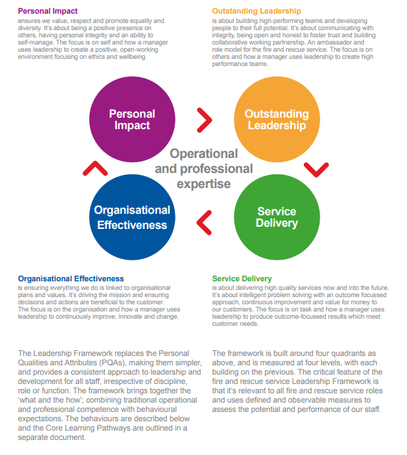
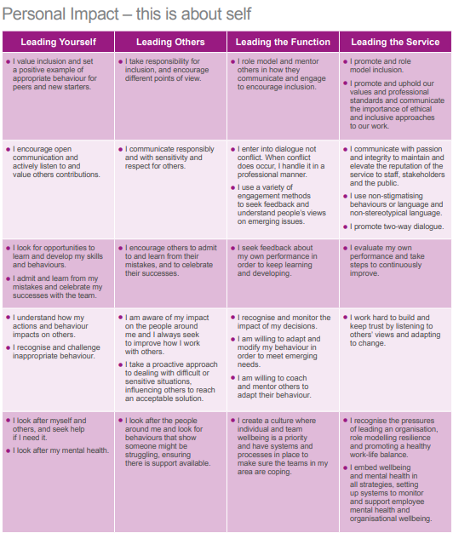

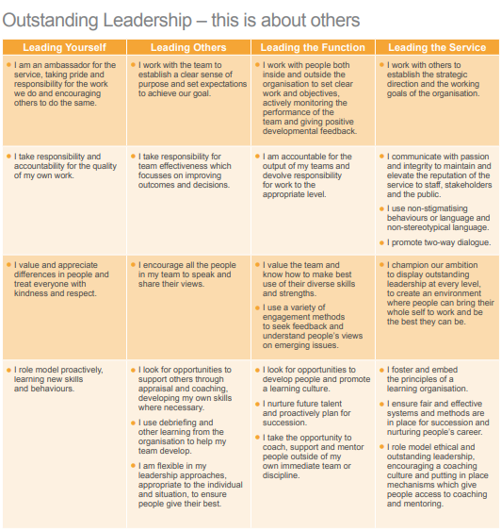

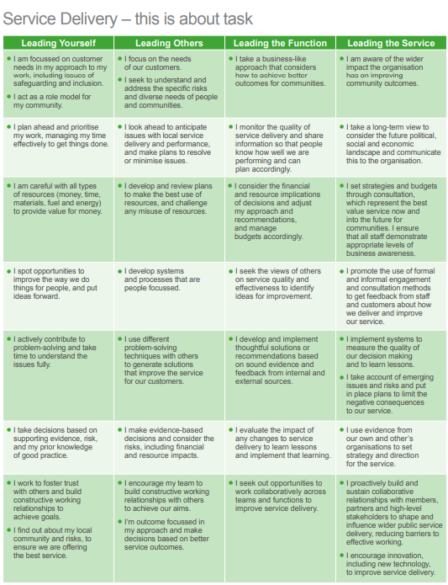

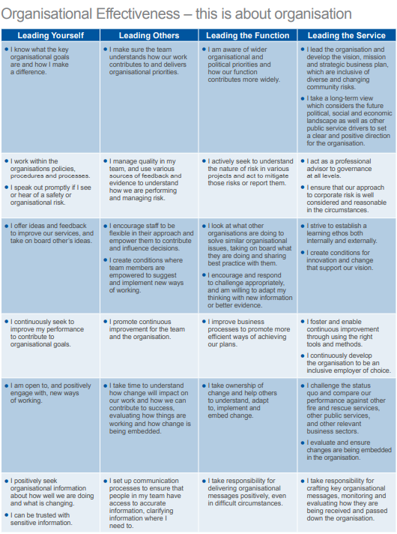

NATIONAL OCCUPATIONAL STANDARDS

The National Occupational Standards for the role are set out below. Further information about them can be found at National Occupational Standards website or by clicking on the links in the table below.

EFSM1 | Provide strategic advice and support to resolve operational incidents
EFSM2 | Lead, monitor and support people to resolve operational incidents
EFSM4 | Plan organisational strategy to meet agreed aims and objectives
EFSM5 | Plan implementation of organisational strategy to meet objectives
EFSM7 | Evaluate organisational performance against agreed measures
EFSM8 | Lead organisational strategy through effective decision making
EFSM13 | Select personnel for employment
EFSM14 | Manage the performance of teams and individuals to achieve objectives
EFSM15 | Develop teams and individuals to enhance work based performance
EFSM16 | Manage yourself to achieve work objectives
EFSM20 | Exchange information to ensure effective service delivery

ABOUT
NORTH YORKSHIRE,
NORTH YORKSHIRE FIRE AND RESCUE SERVICE
AND
ENABLE NORTH YORKSHIRE

North Yorkshire

- North Yorkshire Fire and Rescue Service serves the communities of North Yorkshire and the City of York. The population of 819,800 is spread across isolated rural settlements and farms, market towns and larger urban areas such as York, Harrogate and Scarborough.

- North Yorkshire is England’s largest county, covering an area of almost 3,212 square miles. It stretches from the North Sea in the east to beyond the Pennine watershed in the west and from the Tees in the north to the Ouse and beyond in the south. This provides particular challenges associated with rurality and travel distances.

- The county has two of England’s ten national parks, three designated areas of outstanding natural beauty, over 200 sites of special scientific interest and over 12,000 listed buildings.

- The A1M and M62 motorways, the A66, A59 and A64 major roads and the East Coast Main Line from London to Edinburgh run through the county.

- North Yorkshire contains several important waterways including the River Ouse – the third busiest river in England.

- Major industry includes Drax, one of the largest power stations in the country.

- The county also contains a number of military establishments including Catterick Garrison, the largest British Army Garrison in Western Europe.

- North Yorkshire, with its national parks and over 800 tourist attractions, receives more than 20 million visitors each year.

- Agriculture is the main industry outside of the main towns.

- The City of York is home to over 21,000 students, with two universities, drawing students from all over the world. Significant employers in this area include companies in IT, financial, transport infrastructure and manufacturing.
North Yorkshire Fire and Rescue Service

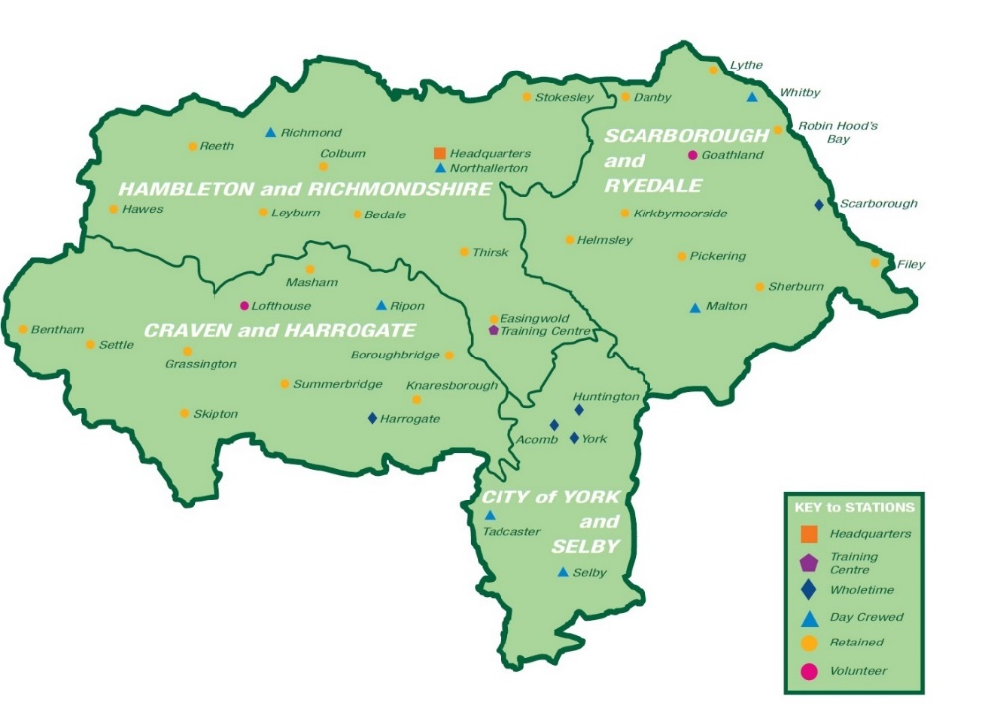

- Our more urban areas have shift stations, larger market towns have day crewed (self-roster) stations and smaller towns/rural villages have on-call. We also have two volunteer stations.

- Around 55% of our operational staff are on-call firefighters.

- There have been a number of changes within the service recently, including changes to the governance arrangements and to the Senior Management structure

- North Yorkshire Fire and Rescue has an ambition to be a flexible, agile, effective and financially stable service delivering value for money to the public we exist to serve – by 2025. We will deliver the vision and priorities in the Fire & Rescue Plan through a Risk and Resource model that is based on risk, demand, availability and affordability. We will help everyone in York and North Yorkshire feel safe and be safe. To achieve this, we will require a keen focus on finances to ensure that savings are developed to re-invest in priority areas.

As part of the transfer of fire governance, the Commissioner set out plans to bring staff in enabling functions together as one team to provide services to police, fire and OPFCC to improve efficiency and affordability across the police and fire services in North Yorkshire.

The new plan involves “back office” departments such as finance, HR, Corporate Communications and IT, as well as others, coming together as one team, under the name Enable North Yorkshire (enableNY). enableNY went live from April 2019 based in the joint police and fire headquarters, with a mission to provide high quality, efficient business support services for both NYFRS and NYP.

enableNY is headed up by Managing Director Ray Ward, who is accountable to both the Chief Constable and the Chief Fire Officer for providing the services needed to support their respective operations. The creation of this post, and the disestablishment of the current Chief Executive functions in both Fire and Police services, represents the first step in a wider senior management review which is currently completing.

The creation of enableNY will not result in any job losses. Both Police and Fire services have
recently completed a programme called Transform 2020 delivering greater efficiency in both organisations.

- The functions (both NYP and NYFRS) included in enableNY are listed below:
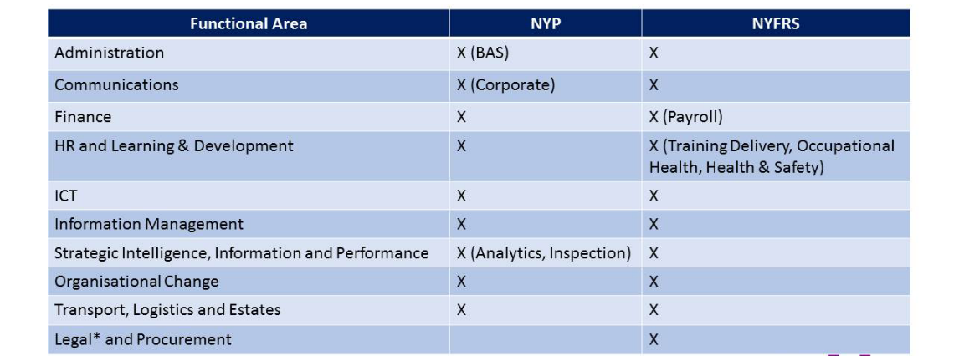

*NYP's legal team is not included as Evolve, a collaboration with Cleveland and Durham police forces, is the existing collaboration agreement through which NYP legal services are provided.
Outline organisational structure
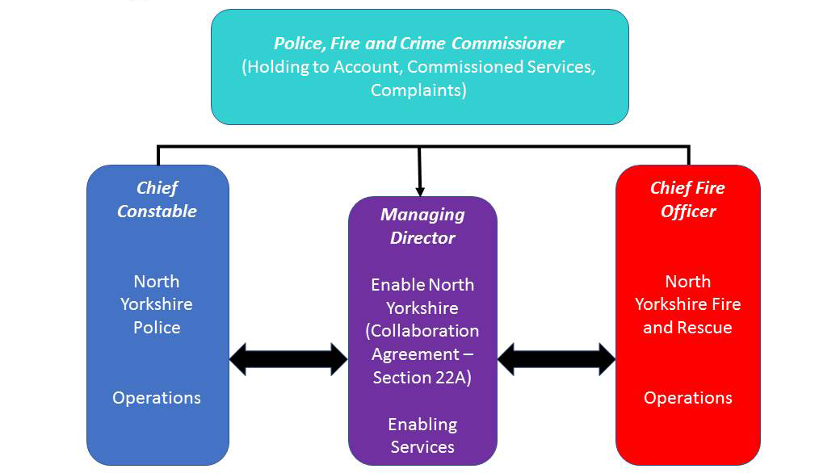

TERMS AND CONDITIONS

Appointment
The appointment will be made on a conditional basis subject to references and appropriate medical clearance, including the completion of a pre-physical questionnaire, fitness test and health surveillance as standard practice.
The offer will be also be subject to Non-Police Personnel Vetting Level 3 (NPPV 3) and National Security Vetting at Security Check (SC) Clearance.

Confirmation hearing
The Commissioner will make an appointment subject to a Confirmation Hearing by the Police, Fire and Crime Panel. The date of this hearing will be confirmed in due course and the successful candidate will be invited to attend.

Salary and development
The gross salary for Chief Fire Officer is £121,352-£133,837, inclusive of operational allowance.
The basic pay is distributed across a 6-point scale, the starting position of which reflects the level of experience and suitability of role. Progression of the scale could be at an accelerated rate, subject to achieving satisfactory performance against agreed objectives with the Police, Fire and Crime Commissioner.
The Chief Fire Officer will receive an annual NJC-negotiated cost-of-living pay rise.

Relocation expenses
The post holder’s residence should be within a reasonable travelling distance of North Yorkshire Fire and Rescue HQ in Northallerton to fulfil the responsibilities of the post.
Reasonable relocation costs will be considered, depending on the applicant’s circumstances.

Continuous Duty System
All Brigade and Area Managers (B&AMs) are conditioned to a Continuous Duty System (CDS) to maintain Gold Duty Rota. Please refer to the attached link for the policy.
https://www.northyorkshire-pfcc.gov.uk/how-can-we-help/get-involved/vacancies/chief-fire-officer/

Working duty
The post holder will not hold any other appointment or engage in other work except with the prior written consent of the Police, Fire and Crime Commissioner.

Pension
The successful candidate will be contractually enrolled into the Firefighters’ Pension Scheme (FPS) but can opt-out of the scheme should they wish to.
The FPS is comprised of a number of schemes. If the appointee is already a pension scheme member, they will be entitled to remain in their current scheme. The pension scheme protections that currently apply will continue unchanged following appointment. If, however, the successful candidate is not currently a member of the FPS, they will be contractually enrolled into FPS 2015: the scheme available to all new members.
The FPS is administered by West Yorkshire Pension Fund (WYPF) on behalf of North Yorkshire Fire & Rescue Service. Comprehensive information relating to the FPS is available on the WYPF website www.wypf.org.uk.
Normal Pension Age is the age when you can retire and take the pension you have built up in full. The Normal Pension Age differs between the schemes that comprise the FPS; in summary, these are:
- FPS 1992: age 55. Members can, however, retire from age 50 providing they have at least 25 years’ pensionable service. If you are a Chief Officer, and were appointed to the role, before 1 July 2013, you will require permission to retire before age 55
- FPS 2006 (standard section): age 60
- FPS 2006 (retained modified section of the scheme): age 55
- FPS 2015: age 60
It has been agreed that North Yorkshire Fire & Rescue Service will apply abatement to any role to which a retiree from the Firefighters’ Pensions Scheme is appointed following widening of the discretions available to Fire and Rescue Authorities. Abatement is the process of reducing or stopping a member’s pension if a member retires and then returns to work in the public sector. Government policy is that pension payments should be abated where a member is re-employed in the public sector and receives a pension and salary which exceeds their earnings before retirement.
Anyone in the Local Government Pension Scheme is subject to the rules on abatement if they are re-employed and in receipt of a pension.

BACKGROUND READING

Fire and Rescue Plan
The Police, Fire and Crime Commissioner’s Fire and Rescue Plan sets out the strategic vision, priorities and objectives for North Yorkshire Fire and Rescue Service over the next two years for how it will better respond to the needs of our communities.
https://www.northyorkshire-pfcc.gov.uk/fire-rescue-plan/

North Yorkshire Fire and Rescue Service - Integrated Risk Management Plan 2016-2020
https://www.northyorksfire.gov.uk/wp-content/uploads/2021/06/community_safety_plan_jan2018.pdf

Website of the North Yorkshire Police, Fire and Crime Commissioner
www.northyorkshire-pfcc.gov.uk

Annual Report 2019/2020
https://www.northyorkshire-pfcc.gov.uk/fire-oversight/governance/annual-report-fire/

Corporate Governance Framework
https://www.northyorkshire-pfcc.gov.uk/content/uploads/2019/04/North-Yorkshire-Police-Fire-and-Crime-Commissioner-Fire-and-Rescue-Authority-Corporate-Governance-Framework.pdf

Ambition 2025
http://northyorksfire.gov.uk/wp-content/uploads/2021/05/NYFRS-Ambition-2025-1.pdf

Service Strategies
http://northyorksfire.gov.uk/wp-content/uploads/2021/05/Service-Strategy-2020-to-2025-1.pdf

Service Values
http://northyorksfire.gov.uk/about-us/who-and-what/vision-and-values

Medium Term Financial Plan
https://www.northyorkshire-pfcc.gov.uk/fire-oversight/budgets-and-expenditure/fire-financial-planning/

HMICFRS Effectiveness, efficiency and people 2018/19
https://www.northyorkshire-pfcc.gov.uk/fire-oversight/governance/hmicfrs-fire-service-inspections/

HMICFRS Covid-19 Inspection
https://www.northyorkshire-pfcc.gov.uk/fire-oversight/governance/hmicfrs-fire-service-inspections/

NFCC Leadership Framework
NFCC_Leadership_Framework_Final.pdf (nationalfirechiefs.org.uk)

